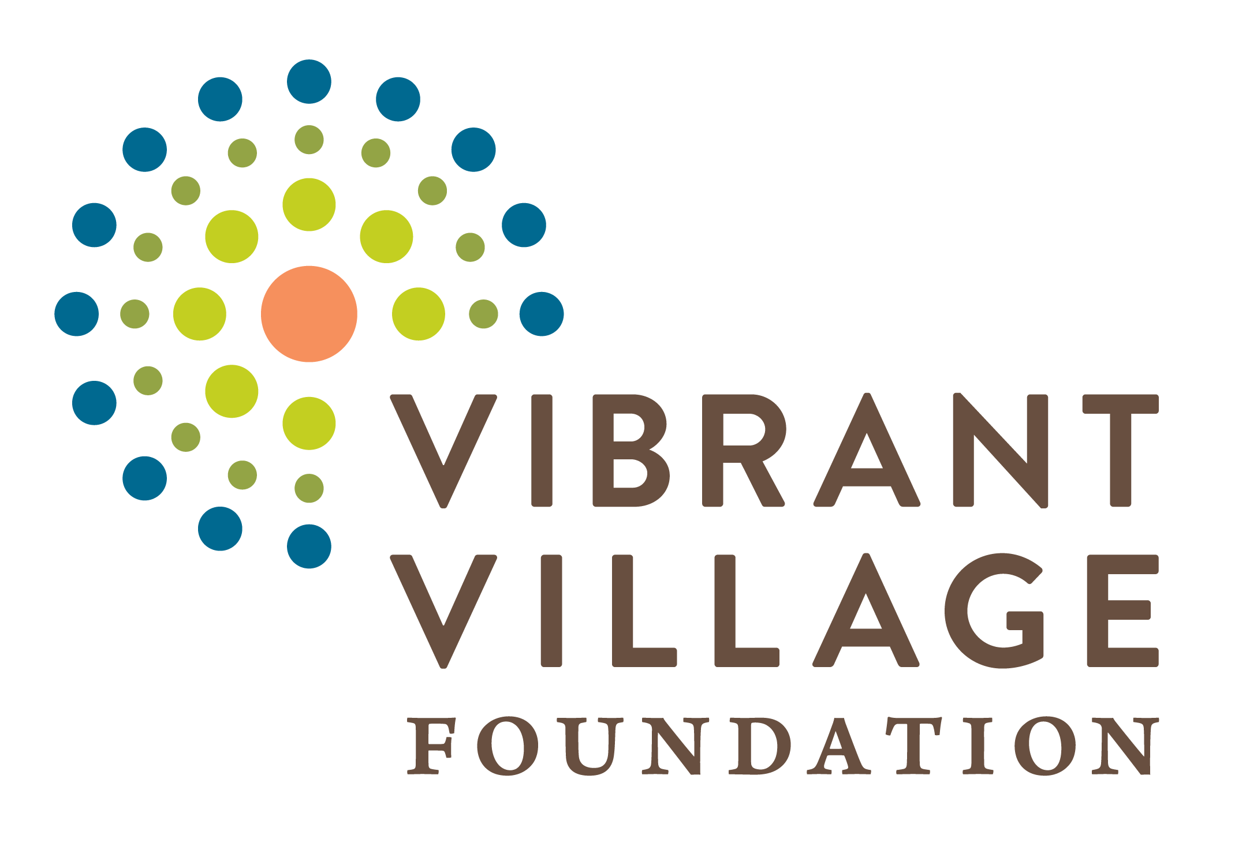

BEGA KWA BEGA
Annual Report
1st July 2015 – 30th June 2017
Date of submission: 16th/08/2017

SUMMARY TABLE
Community/Village: | Kamuli, Wagaba, Kabagezi and Namagera
County/Province: | Busiro County
District/Region: | Wakiso
# of direct participants* | 5374
# of households* | 3283
# of total beneficiaries (includes participants and members of household who also benefit)* | 16, 415
Current community situation/problems: | Increased knowledge about traditional medicinal plants, improved knowledge on nutrition, health, hygiene, environmental management practices.  Good farming techniques and awareness, improved seeds and food availability and variety. Increased access to safe and clean water.  Improved nutritional status of individuals & improved hygiene & sanitation, production of income generating food products.  Nonetheless there is still lack of health facilities, dwindling government support to health, costly medical care, no reliable source of income for most people, low levels of education, costly agricultural inputs, and lack of market information.
Project components: | Agriculture, Nutrition, Health, Water, Income Generation, Education.
Total Grant Award: | 107,918
*For people or households involved in more than one project, please only count them once.

EXECUTIVE SUMMARY
½ page description of major achievements, any key learning, and any challenges of the quarter.
This report marks the end of a two year project on Water and Nutrition for Health and Self-Sufficiency in Uganda supported by Vibrant Village Foundation (VVF). The project was implemented in 4 villages of Kamuli, Wagaba, Kabagezi and Namagera that are located in Kakiri Sub County, Wakiso District, in central Uganda.

Residents of these villages are subsistence farmers with low levels of education, no reliable source of income and depend on produce from their land to feed their families which was insufficient and unbalanced leading to widespread malnutrition. This was attributed to poor farming practices, seasonal drought, poor quality seeds and limited farm skills. Water was scarce and typically drawn from creeks and streams and shared with livestock. Coupled with the above challenges is lack of health facilities and strong superstitious beliefs. Against that background the purpose of this project therefore is; to enable residents produce enough quality food year round; reduce malnutrition, increase access to safe water and basic health services.
The project which commenced in July 2015 and ran up to June 2017 registered a number of achievements; with some of the main being: opening up more land for food production, 170 gardens have been started, introduction of over 20 new high yielding food varieties, domestication of 13 locally available biorationals for pest and disease management, soil conservation through nutrient recycling/composting, enhancing skills of 78 teachers in teaching and food production, construction of 4 energy saving stoves to reduce environmental degradation and pollution, drilling 4 boreholes to increase access to safe water, nutrition training and food demonstrations to over 238, training in business management, provision of business startup capital to 40 families to boost family income and provision of mobile health services fortnightly in each village. But like any other project it also had challenges like high densities of pests especially during dry periods, inclination of farmers to usage of synthetic chemicals for quick results, loitering animals and birds that destroy crops, irregular attendance and dropping out some participants, failure by some to adopt to the expected standards and resistance by some men who didn’t want their spouses to attend trainings nor bring their children for the feeding program. From this challenge we learnt that women need to be empowered in decision making if we are increase their participation, improve the uptake of services and the success and sustainability of programs. Secondly integration of interventions on food security and nutrition is key in successfully managing food insecurity and malnutrition in rural communities. We also learnt that the MHC is very effective in delivering health services in remote areas where health services are not available or accessible particularly to children, the very poor, old and single mothers.

ANALYSIS OF ANNUAL RESULTS
- Describe the annual results and accomplishments for each project as compared to the original targets stated in the PME Report. In this section, it may be helpful to follow the same project numbering sequence as found in the PME Report.

This project has 5 program areas (Water, Agriculture, Nutrition, Health and Income generation) with 7 specific objectives:
Water
- The incidence of water borne illness will decrease by 50% among children
Here we achieved 100 % of our target. 4 boreholes were drilled; one per village with a water committee established for each borehole. 1800 people (4 schools with about 250 pupils each and about 200 people per village) now have access to safe borehole water with an operational water committee to care and maintain the borehole to ensure it provides clean and safe water year round.
Agriculture
- Over 30% increase in amount, size, and quality of crops and agricultural products.
Analysis of the level of completion of activities under this objective shows that all the planned activities were successfully implemented. Our target was 160 family gardens for 160 families (40 family gardens per village). But we surpassed the target by enrolling 181 farmers. This caused budget constraints especially where materials such as seeds were to be distributed to farmers. This was however very significant because it gave a better platform for technical dissemination so as to influence more people. By the end of the second year we had 99 family gardens with 65 farmers harvesting 3 or more bundles/heaps of food per week. 78 families have 3 or more meals a day. The quantity and variety of foods produced in the 8 schools that received the kit has increased. The above implies that we were on track and managed to achieve the proposed outcomes and outputs.
Nutrition
- Residents produce and consume enough food to have at least two balanced meals a day per family.
All the planned activities under this objective were completed successfully achieving 100% of our target. The number of meals consumed has risen from 2 to five per day due to increase in food production, food variety and availability. 227 residents benefited from the nutrition and cooking classes, achieving 183.1%. This was above our target of only 160 people in the 4 villages.

- Increased age appropriate growth among children
The percentage child growth rates also rose from our target of 60% to 97.9% (average for the 2 years). With the acquired knowledge and skills in nutrition, mothers and guardians can now plan and prepare balanced meals for their families from home grown or locally available food.

- Reduced cases of malnutrition among children
Out target was 60 children for the feeding program although our baseline shows 9 children. We had to give an allowance because some caretakers are reluctant to bring their children at the start until they notice a change in enrolled children. While others may not be around at the time the nutrition assessment is done. Besides children born to poor parents rarely have steady growth. Their nutrition status keeps fluctuating; the reason we had to carry out continuous assessments to identify and redress such situations. Otherwise all planned activities were undertaken resulting in a reduction of malnourished cases from 26 to 2. Only 2 children didn’t fully recover from moderate malnutrition status. The Body Mass indices (BMI) show great improvement in children’s nutrition status. Their BMI was 1.83 on average; up from -1.132 (˃ -3 is severe, ˃ -2 is moderate and ˂ -2 is normal according to WHO). On a general note, there was a remarkable reduction in malnutrition.

- 50% fewer visits to mobile health clinics
We held 47 mobile clinic sessions above the planned 40, achieving 130% of our target. However given the limited number of clinic sessions (only about 9 per village held fortnightly) it wasn’t possible to reduce the MHC attendees. Majorly because attendees of the MHC don’t come from one specific village; some come from neighboring villages. Secondly supplementary efforts by government aided village health teams (VHTs) had been stopped by government on grounds of incompetence. This coupled with lack of drugs at government health facilities led to persistent rise in numbers in the subsequent clinics reducing only during the rainy season when locals are busy with gardening/farming. In Uganda we also have an overwhelming numbers of a young population below 30 years (78%) that is prone to infection.

- The number of low-birth weight babies will decrease
This objective was an oversight because the mobile health clinic doesn’t provide maternity services which make it difficult to determine the weight of newly born or monitor their growth. In addition not all children are born at health centers where their weights can be taken. Some mothers deliver on their own while others with the help of traditional birth attendants. However 43 health improvement workshops were held on aspects such as antenatal care, nutrition, family planning, immunization, exclusive breastfeeding and complementary feeding in which 147 pregnant mothers benefited.

- Family income to increase by 30%
Here we achieved 100%. The two planned activities were trainings in business management and providing startup capital to 40 participants which was successfully done. 40 small businesses were started. The result was a 67% increase in family income in the first year (Kamuli and Wagaba villages). Year two impact assessment has not been done yet because beneficiaries just got the startup capital in June this year.

- Increase in business opportunities in the area
To achieve this objective we had planned to supply 20 different cash crops but we went beyond that target and supplied 37. This has led to an increase in cash crop production leading to a rise in average family monthly income from 51,667 to 71,850 Uganda shillings thus achieving 112%.

- Did you achieve or are you on track to achieve the proposed outputs and outcomes? (see table below)

Summary of outputs and outcomes and their level of achievement
 | Indicator | target | Achievement | Comments
 | Water
1 | % reduction in incidences of water borne illnesses | 100% (50% per year) | 74% | We may not have achieved 100% but we went above the annual target of 50%
2 | # of people using the borehole | 1800 (800 residents & 1000 school children) | 1800 | 100% achieved
3 | # of trained water committees | 4 (1 per borehole) | 5 water user committees | 125 % achieved. We got a discount from the driller and used the balance to drill another borehole.
 | Agriculture
4 | # of family gardens | 160 (40 per village) | 170 (71 & 99 year 1 &2 respectively) | 113.3% (average for 2 years) achieved. More people turned up than budgeted.
5 | # of training sessions in farming methods. | 248 | 231 | 93.3% achieved. Poor weather, social functions and health issues and public holidays at times hindered/collided with the training rota.
6 | # of people harvesting 3 bundles/heaps of food a day | 160 households | 118 | 74% achieved. We fell short of 100% because of slow adopters and the poor weather.
7 | # of people eating 3 or more meals a day | 160 households | 135 | 84% achieved (as above)
8 | # of science kits supplied to schools | 8 | 8 | 100% achieved
9 | # of energy saving stoves constructed | 4 | 5 | 125% achieved. Used balance to construct one more stove.
 | Nutrition
10 | # of meals per day | 5 | 5 | 100% achieved
11 | # of nutrition meal planning workshops | 248 | 347 | 140 % achieved. We had a balance on the feed program because of small numbers which we put into workshops.
12 | # of malnourished children on the supplementary feeding program | 60 | 26 | 57% Some caregivers refused to enroll their children, others migrated while others preferred helping them from their homes.
13 | # of people trained in nutrition | 160 | 238 | 149 % achieved. Many picked interest seeing the food demonstrations and learning that they could prepare nutritious food for home consumption & income generation from locally available food.
14 | % child growth rates | 60% | 97.9% (average for 2 years) | Above target
15 | Body Mass Indices | ≥-2 | 2.665 average | Above the target
16 | # of people trained in hygiene & sanitation | 160 households | 215 | 134.4% others picked interest later after learning of the benefits.
 | Health
17 | # of attendees of the MHC | 3400 | 7634 | 225%. Neighbours of Kamuli, Wagaba, Kabagezi and Namagera villages also attended the clinic.
18 | # of MHC Sessions and health workshops | 40 | 47 | 117% achieved. Had a balance which went to the clinic.
19 | # of women who received prenatal care | 200 | 147 | 74% Majority of women go to traditional birth attendants (TBAs) because they are more accessible, cheap, preferred.
 | Income generation
20 | % increase in family income | 30% | 67% | 67% (for year 1 alone. Year 2 is pending because we have just given out the capitation.
21 | # of trainings in business management | 2 | 2 | 100% achieved
22 | # of businesses started | 40 | 40 | 100% achieved
23 | Savings | 64,000/= | 71,850/= | 112% achieved for year 1 only. Year 2 pending
24 | # of cash crop types grown | 20 | 37 | 185%

- What is your analysis of these results, what does it reveals (or does not reveal) about your programs? Can you put this into context so we understand the impact of these results?
(Ex: You may report that farmer earned $500 more in revenue from their rice crop, but what does that increase in income mean for these farmers?)

The analysis reveals that program was largely a success. Out of the 24 targets set 16 were achieved and the remaining 8 are above 50%. The MHC clinic has greatly benefited the community. It was highly valued because of its informal setting, convenience, familiar environment, medical staff that were easy to talk to. Many who had very limited access to medical care got an opportunity to be heard, talked to, educated, counseled, and reassured and also save money spent on drugs and movements to health centers. This is what one beneficiary had to say; “I have saved over 70% previously used on medication to pay fees for my daughters”.

Kilyowa who was a peasant is now a full time employee. With the knowledge and skills acquired in organic farming and business management he earned himself a job as a banana plantation manager. He manages a plantation belonging to some commercial farmer at his village. Today, Mr Kiryowa earns a monthly salary of 300,000/=. This is real evidence that the project has impacted the community in terms of income, food and other aspects of life. For example this person can use 50% of his monthly salary to pay school fees for one child at primary level in one year (in a rural school).
For the first time in 20 years Mariam Jingo of Kabagezi village earned 80,000/= from vegetables on her small piece of land of approximately 0.05 decimals in one season. Seeing the benefits she has decided to take on vegetable farming. She has got a wide market at Bukalango church earns 10,000/= from weekly and about 40,000/= monthly.
Roy Nagulire, the director of New Generation Primary school has opened a garden for her school which provides a daily source of different vegetables and vitamins for the children every day even during draught. The borehole (VVF) provides water for irrigation and the children provide free labour. The school used to spend 25,000/= on beans every week but now it saves about 100,000/= every month which goes towards school development.

When you move around the village you will clearly see several designs of gardens bearing several food crops supporting lives of very many farmers. Many have interestingly nicknamed the seeds of beans as ‘Bega beans’. Of the various crops grown for example, farmers are able to sell up to at least 50 kilograms at 2500/= each giving a total of 125,000/=. This income can buy two piglets that are sufficient enough to start a new business as a way of economic diversification. We can also say that at least each farmer has a kitchen garden at home.

Collaboration among participants like the women who teamed together to rent more land to plant more crops for sale has increased family income.

Sustainability resulting from participatory methods of training promoted deep leaning; resident peer trainers and coaches and village models of family gardens enable ongoing learning and mutual support.

- Discuss the challenges, opportunities and unexpected outcomes experienced during the past year

Challenges
- The expected number of participants increased from 160 participants in the four villages to 170 participants. This strained our budget it terms of supplies like seeds. We rationed these inputs. We also encouraged use of locally available resources such as bi-rationals (organic pesticides).
- Impassible, muddy, slippery and dusty roads gave us hard time during transit from one village to another. We secured protective gears and always moved early enough to avoid delays.
- The irregular attendance of participants also delayed adoption of the trained skills. However we decided to meet such individuals at their homes and help them.
- Overwhelming number of attendees at the mobile Health clinic sessions from neighboring villages leading to drug shortages.

Opportunities and unexpected outcomes
The unexpected outcomes below are rooted in existing opportunities people had not exploited before the project:
- While at the demos, farmers got an opportunity to meet, pull resources together, save and pursue internal lending among themselves.
- Edward Musoke of Kabagezi village is now self-employed. He has started agro- processing; making tea additives from soya beans, jabula, okra and ovacado seeds. He buys produce at 3500/= from fellow farmers to make the additive which also has a medicinal value. He produces 10kg weekly at a cost of 12,000/=. Sells the product at 2000/= per 20ml pack earning himself 100,000/= weekly. The aroma, flavour and taste of his products has opened up a market that is too big for him to satisfy.
- Mariam Jjingo and Lukanga Sulaiman of Kabagezi and Kamuli villages respectively hired to set up good gardens to farmers within and outside the project area. They earn between 10,000 and 50,000 a day whenever they are hired. Lukanga’s pride is that he even travels outside his village to guide farmers design and set up gardens.
- At Kamuli village farmers have co-operated and hired 3 acres of land which they jointly use to grow vegetables and spices which they sell at high prices at Nakasero market in the city center.Nakasero is one of the biggest markets in Kampala.

- [For multi-year grant only] For next year, what will be changed? Are there changes in the community significant enough to affect the scope of the program? Have the targets changed? Does the budget need to change?

- Submit one story, either a beneficiary profile, or other story that highlights the impact of your program this past year. Please upload 5-10 photos to Dropbox that relate to this story and your work this past year.

Stories
At Namagera village, Bazibu Isaac has opened up a road site food kiosk. This combines locally grown foods such as carrots, cabbage, beans and other greens to make marketable products such as samosas that are sold. He commends the training from BKB that enabled him acquire knowledge that is making him self-employed. He earns between 10,000/= and 15,000/= per day. The rest of the trainees in this village get an opportunity to sell their products to this kiosk.
Jalia Kikonyogo of Kabagezi is now assured of a daily income. She makes daddies (small doughnuts) daily. She only has to buy 2kg of baking flour at 5200/=, ½ kg of sugar at 2500/= (used for several cookings), cooking oil at 6000/=, baking powder at 1000/= (used in 4 cookings). With a weekly investment of 14,700/= she earns between 20,000/= to 22,000/= per day and between 100,000 – 154,000 weekly. Her weekly profit is 75,600/=. With that Jalia is now an independent woman, able to meet most of her household needs.

Nakitto Esther, a teacher at Namagera Primary School has survived a transfer to a distant school because the head teacher wanted her to train fellow teachers and students on how to grow several food crops. She also supplies the school with vegetables earning her some side income.
The MHC has been able to provide health care to areas that most health practitioners would not work. Additionally they have provided a range of free services from basic treatment, sensitization services, counseling to drug alternatives an area traditional hospitals dare not speak about for fear of losing the would be clients (patients).
Bega kwa Bega would like to thank the Vibrant Village Foundation for this grant. It gave us the first opportunity to implement our whole program in a rural village. It has confirmed that our way of doing things in a holistic manner within and with the village itself is a successful way of doing our humanitarian outreach. It has also given us the opportunity to refine our methods and has helped identify areas that may need additional effort. Perhaps the best testimonials to the way the program was conducted is the fact that some of the current beneficiaries are now going out to nearby villages on their own to help others as we have helped them. Another confirmation is the way they showed Bega kwa Bega their appreciation at one of the dedication celebration where they gave us a large commemorative wall clock and many expressions of appreciation and thankfulness. All the residents of the 4 villages, their leaders are grateful to VVF for transforming their lives through the knowledge and skills acquired.
In summary, this grant not only helped individuals within the village but greatly benefited the village as a whole. It brought people together and let them see how working together helps everyone. It also gave the village a new outlook as noted by some of the chiefs' or village elders' comments.
We feel that we have met one "goal" that we had set for ourselves - to develop, implement and test a program format that is successful and can be used by others as a more or less "STANDARD PROCEDURES" on how to do these types of projects in the future.
Again thank you for your generosity and guidance. We are proud of what we accomplished and hope to continue doing more in the future.

